**IM3080 Design and Innovation Project**

**(AY2021/22 Semester 1)**

**Project Report**

**Title:** Jio

**Github:** <https://github.com/Eve-ning/DIPProject>

**Submitted by:** Dip Group 3

**Supervisor:** Assoc Prof Chua Hock Chuan

Contents

1. Background and Motivation
2. Objective
3. Review of Literature/Technology
   1. *Forest*
   2. *Gather*
4. Design and Implementation
   1. Design Consideration / Choice of components
      1. 8-bit theme
      2. Color palette
      3. Avatars
      4. UI/UX
   2. Final Design (with block diagrams)
      1. User Flow Diagram
   3. Implementation
      1. Multiplayer supported
      2. Tilemaps
         1. Isometric Tilemap
         2. Tilemap Elevation and Rendering
         3. Tile Details and Animation
         4. Lighting and Normal Mapping
         5. Tilemap Themes
      3. Animations using State Machine Programming
      4. Multiplayer Networking
         1. Photon Overview
         2. Clients, Instances & Server
         3. Photon Views
         4. RPC & Raise Events
         5. Photon Room System
         6. Photon Chat & Voice
      5. Database
5. Conclusion and Recommendation
   1. Conclusion
   2. Recommendation for Future Works (sustainability)
      1. Orientation of App
      2. Economics
      3. Diversifying Variables
      4. Background Music & White Noise

## Background and Motivation

With the fickle nature of the Coronavirus pandemic and therefore Singapore’s frequently changing stance on social gatherings, more and more users are turning to online tools to help them stay connected. However, in this technology-driven age, the average attention span of people has decreased drastically. Coupled with the fact that some require working together with others to stay productive, this combination of factors could prove disastrous for their productivity.

## Objective

The two main objectives of our app are to promote both social and productivity in users, with a platform that allows users to stay connected while working together.

The productivity aspect of this app comes in with our timer function in-app that is modeled after a Pomodoro productivity system, which suggests that users will be more likely to focus for longer periods of time if they cycle between short focus sessions, then take a break before repeating the process. Users will be further incentivized to keep returning to *JIO* for focus sessions with rewards such as in-app currency, and collectibles.

*JIO* will also allow users to share a virtual space with their friends in a game-like setting. For users that require the company of others to attain maximum productivity, this feature provides a good alternative to requiring being physically surrounded by people to do work.

## Review of Literature/Technology

### 3.1 *Forest*

Forest is an application that puts a user’s phone in “lockdown” mode when active, where users will be able to set a countdown timer denoting how long they wish to spend off their phones. When a “tree” is “planted” (i.e. a focus session is started), leaving the application will cause their “tree” to “die”, their forging in-app rewards,

### 3.2 *Gather*

Gather is a virtual office app, which allows users to mimic real-world environments online, and therefore serves as a replacement for physical meetups.

## Design and Implementation

### 4.1 Design Consideration / Choice of components

#### 4.1.1 8-bit art style

8-bit graphics style on game platforms is gaining traction, with the world embracing its high potential modernity with a touch of retro. We decided to go with this art style, as it is relatable to a wider range of age groups, especially the modern generation who seem to appreciate pixel art.

We see many map exploration games on the market implementing 8-bit graphics and took inspiration from their seamless character-environment art interactions. Some of the games include Pokemon, Terraria, and Stardew Valley.

The simplistic yet crisp art also allows our styles to remain streamlined and create consistent animation throughout the application. Pixel game art also makes it easier to optimize graphics for handheld devices which is essential for our application that is most likely utilised on an android mobile phone.

#### 4.1.2 Colour Palette

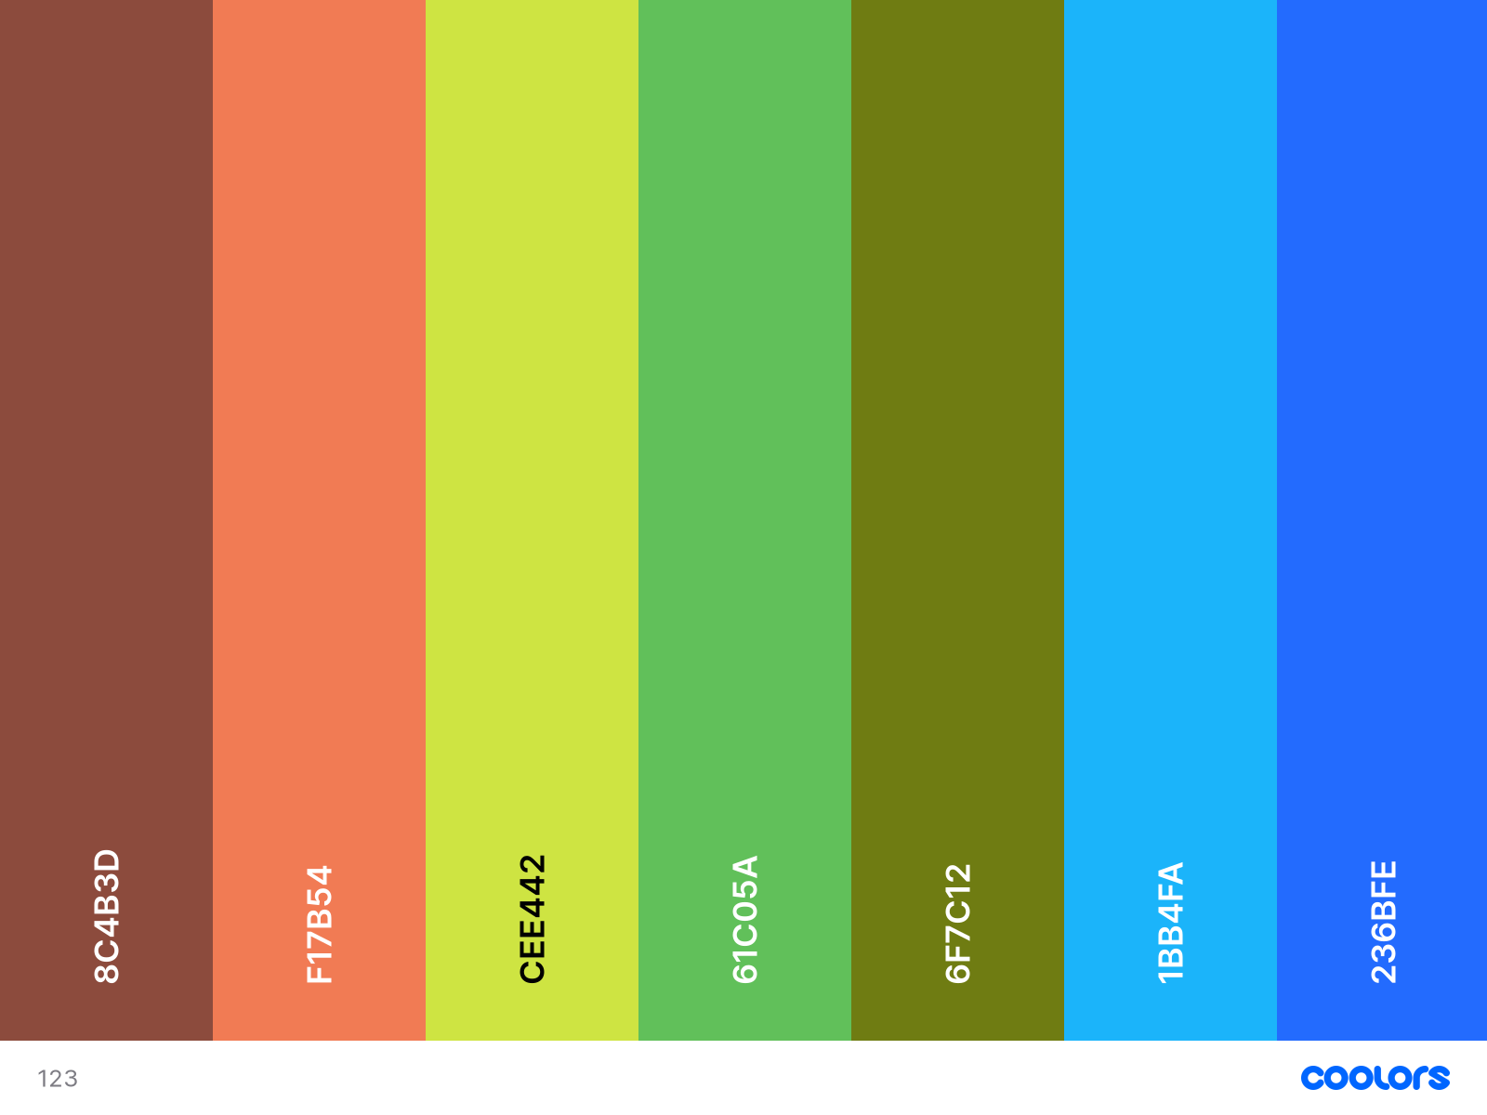

*Figure 1: Environment Colour Palette*

The general colour palette (Figure 1) chosen features colours with hues of red, blue and yellow, as they are known to promote productivity. Additionally, the colours are brighter, which is associated with cheerfulness and can therefore prompt users to associate our app with positivity.

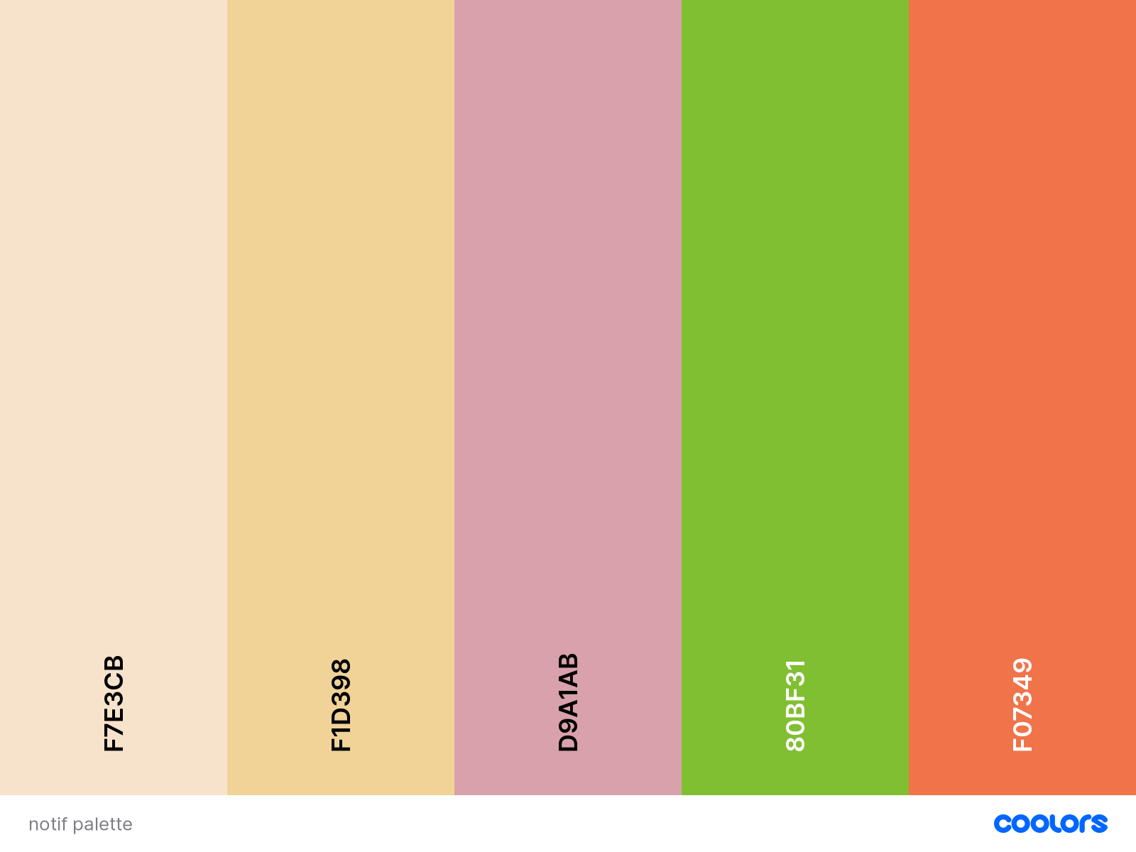

*Figure 2: UI/UX Colour Palatte*

Comparatively, the palette chosen for UI/UX (Figure 2) is more muted, so as to contrast against the more intense background. The colours chosen are also easier on the eyes, to prevent pop-up menus and other system functions from being too intrusive.

#### 4.1.3 Avatars

To fit with the 8-bit art style map, a round-body style cat was chosen as the character for our app. The cats have different actions corresponding to the things they do. Some actions include walking, idling, and fishing, facing four different directions. Since all the cats were drawn from scratch, multiple frames were needed to animate each of the movements.

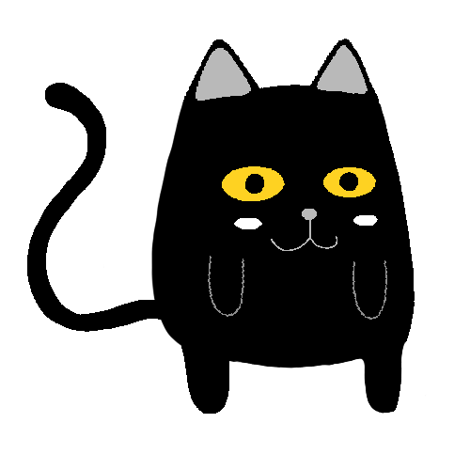

*Figure 3: 4 Unique Cat Avatars*

Currently, we have 4 cat designs (Figure 3), namely Black, Garfield, Jiggly and Pusheen. Users can choose any character that best suits them before starting their “fishing” expedition.

#### 4.1.4 UI/UX

The term UI refers to “User Interface” design and UX refers to “User Experience” design. Since *JIO* revolves largely around a game-like setting, the use of graphics would be of utmost importance to the app’s appeal.

Firstly, the aim is to create interfaces that users find easy to use and pleasurable. As such, main action buttons such as "Create/Join Expedition" are designed larger to be more prominent. They are also placed appropriately to guide users on their exploration and social interactions within the app. All buttons and pop-ups are also shaped with rounded edges for a softer overall look. Pop-ups and icons' colors were also chosen with reference to the color palette so that they can complement for a better fit.

In order to facilitate a better experience for the user, an intuitive and user-friendly interface is our main priority. Only necessary icons are included so as to not make the interface look too crowded or messy. Furthermore, animations such as the characters' actions and water movements are also added to make our app more dynamic even when users are idle.

All visual elements are specially designed with the user's experience in mind.

### 4.2 Final Design

#### 4.2.1 User Flow Diagram

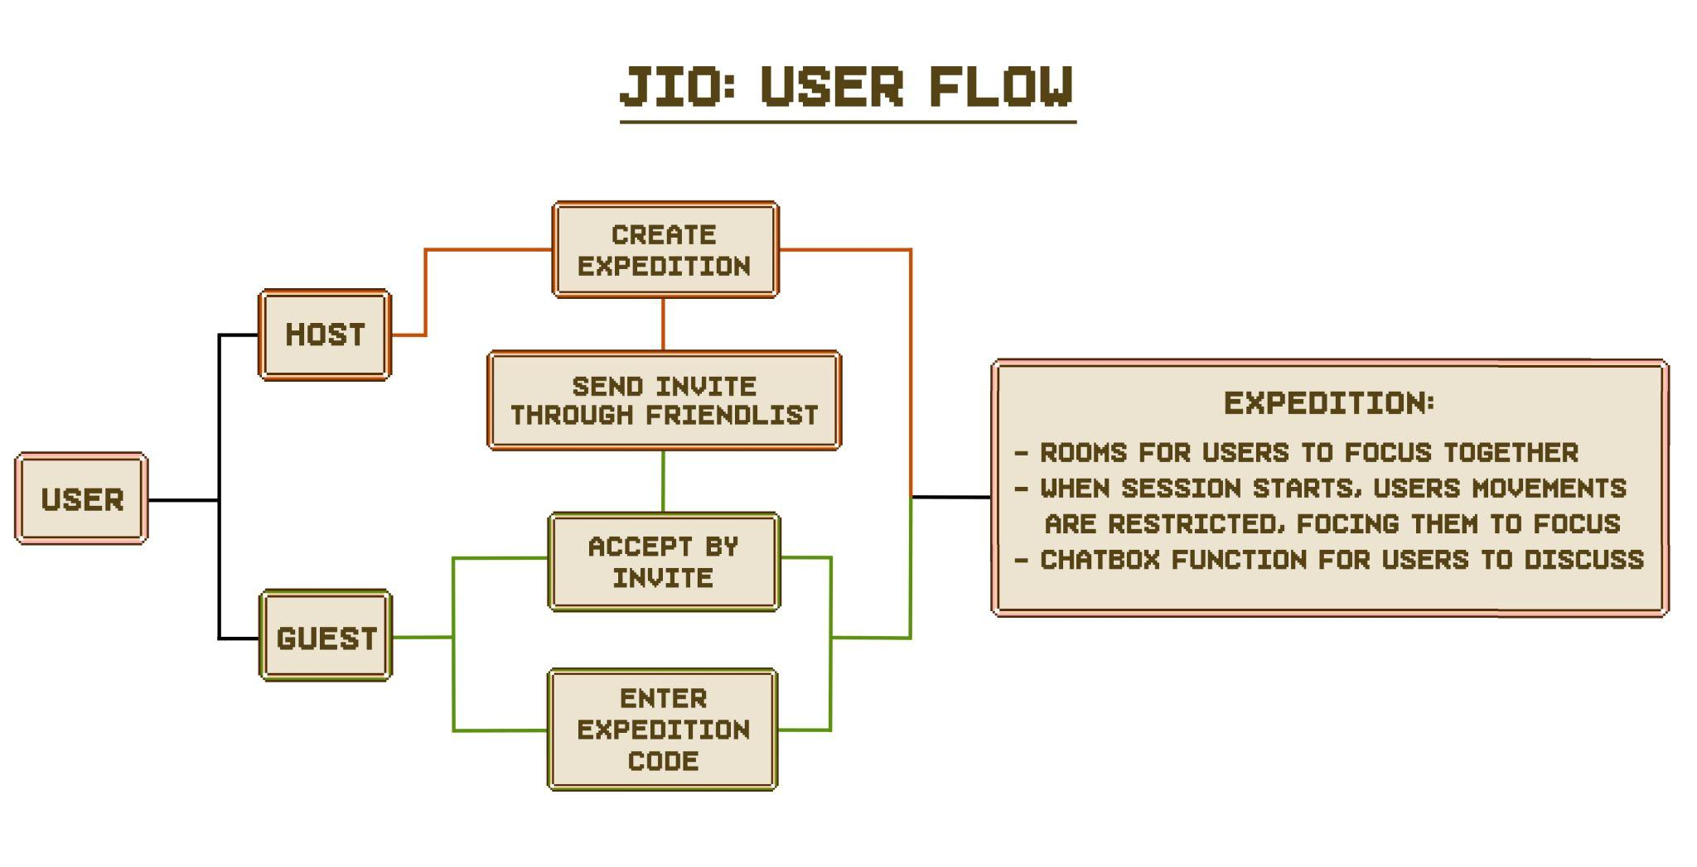

*Figure 5: User Flow Diagram*

Upon launching the app, users will first be taken to a splash screen where they will enter their login credentials before being taken to the landing screen (user).

From the landing page, users can either assume the role of a host or a guest, by choosing “create expedition” and “join expedition” respectively.

Hosts can create expeditions, meaning they will gain access to controls such as how long the focus session will be, as well as the ability to invite their friends to join the expedition.

Guests, on the other hand, can enter others’ expeditions by either entering a unique room code or by accepting an invite from their friends.

Lastly, hosts will be able to start the expedition once they are ready. Once the session has started, users’ movements will be restricted, and they will only be allowed to access the chat functions. This is to ensure that users are not easily distracted by other in-app functions.

### 4.3 Implementation

#### 4.3.1 Multiplayer supported app

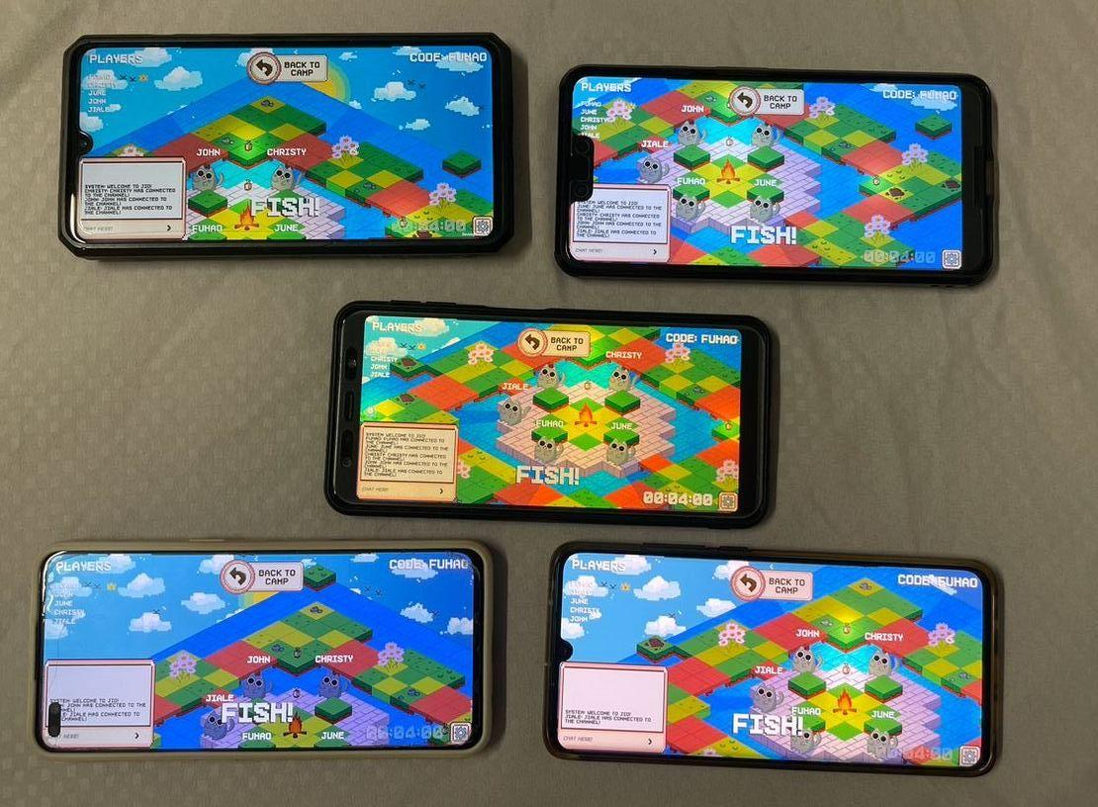

*Figure 6: All players loaded into the same expedition room*

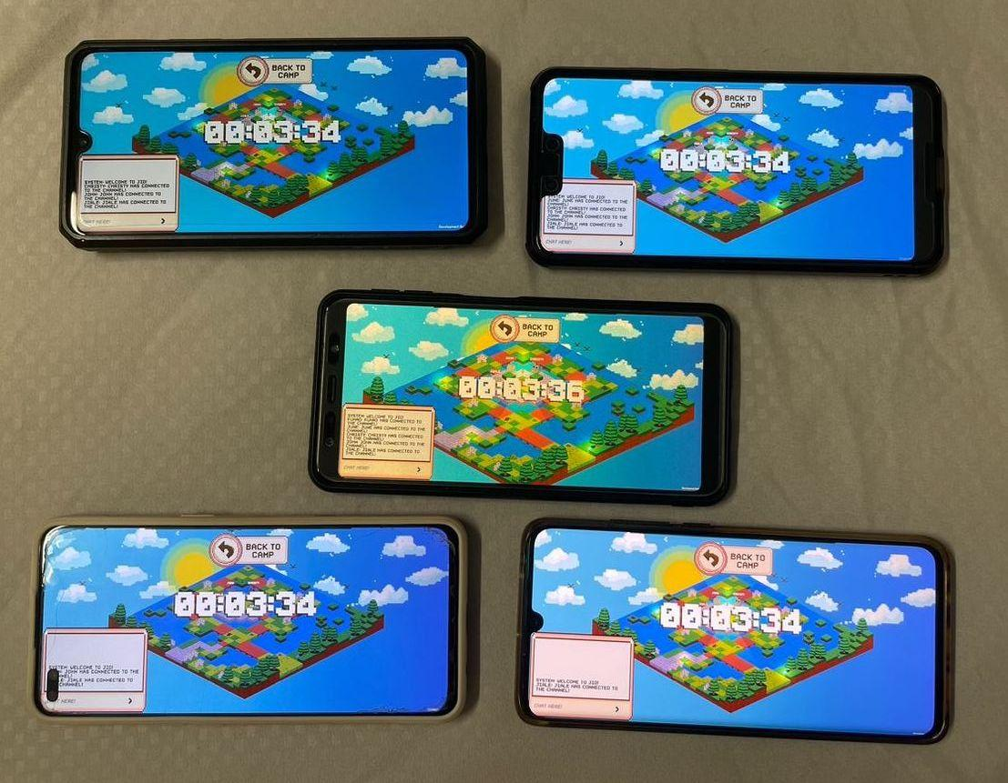

*Figure 7: All players in an ongoing focus session*

#### 4.3.2 Tilemaps

### 4.3.2.1 Isometric Tilemap

A tilemap is essentially a game object that we place tiles on, and isometric tilemaps are used for this game. Isometric projection is an interesting method of visually representing 3D objects in 2D space. They are diamond-shaped, unlike conventional square-shaped tiles.

Our tileset is custom designed and drawn on Photoshop to bring out the different colours and environment of each map we planned on. The process of importing tiles into a Unity tile palette is simple. To create a new tilemap, we would insert a new tilemap into our scene and just ‘paint’ a selected tile from the tile palette (Figure 8).

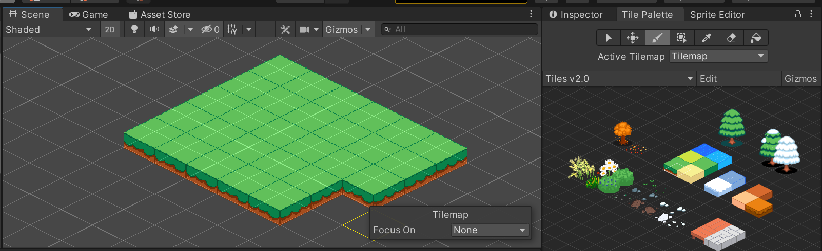

*Figure 8: Scene view containing a tilemap (left) and tile palette with custom tiles (right)*

### 4.3.2.2 Tilemap Elevation and Tilemap Rendering

To create elevations in our tilemap, we can simply create another tilemap in the scene which would be another layer of tiles (Figure 9). In order for Unity to recognise this layer as the elevated tilemap, we would need to adjust its tile anchor as well as set its render order to be higher so Unity will render the elevated layer last.

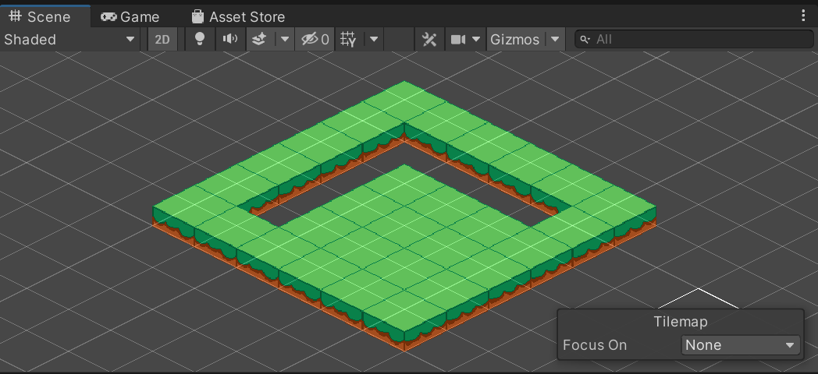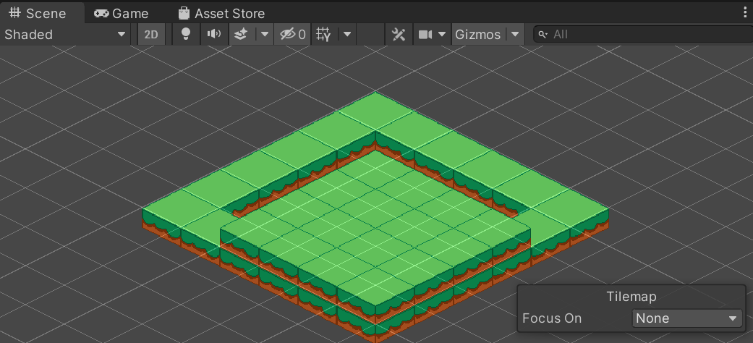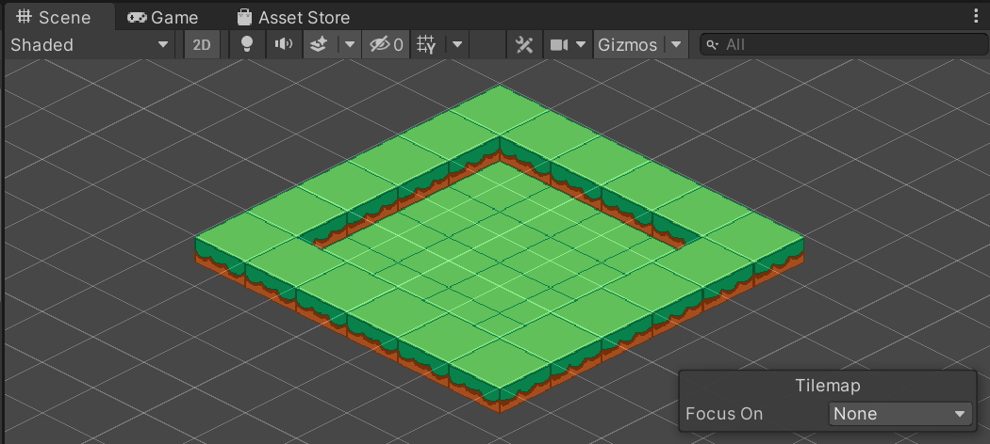

*Figure 9: New tilemap is inserted, followed by adjusting tile anchor, and raising render order*

Additionally, tilemap colliders would be added below the elevated tiles, on the same layer as the original ground. Colliders define the physical boundaries of where the cat cannot walk on. Tilemap colliders are applied to elevated tiles, water tiles and tiles with a tree on it.

### 4.3.2.3 Tile Details and Animation

Tile details such as trees, grass, rocks, and mud are custom-drawn to bring more life to our expedition. Additionally, a manual script is added to prevent Z-fighting between the cat and the ground objects like grass and rocks due to them being on the same plane (Figure 10).

The Y-axis sorting code that compares the height of cat to ground objects is as follows:

| if (objA.y < objB.y) show(objA)  else show(objB) |
| --- |

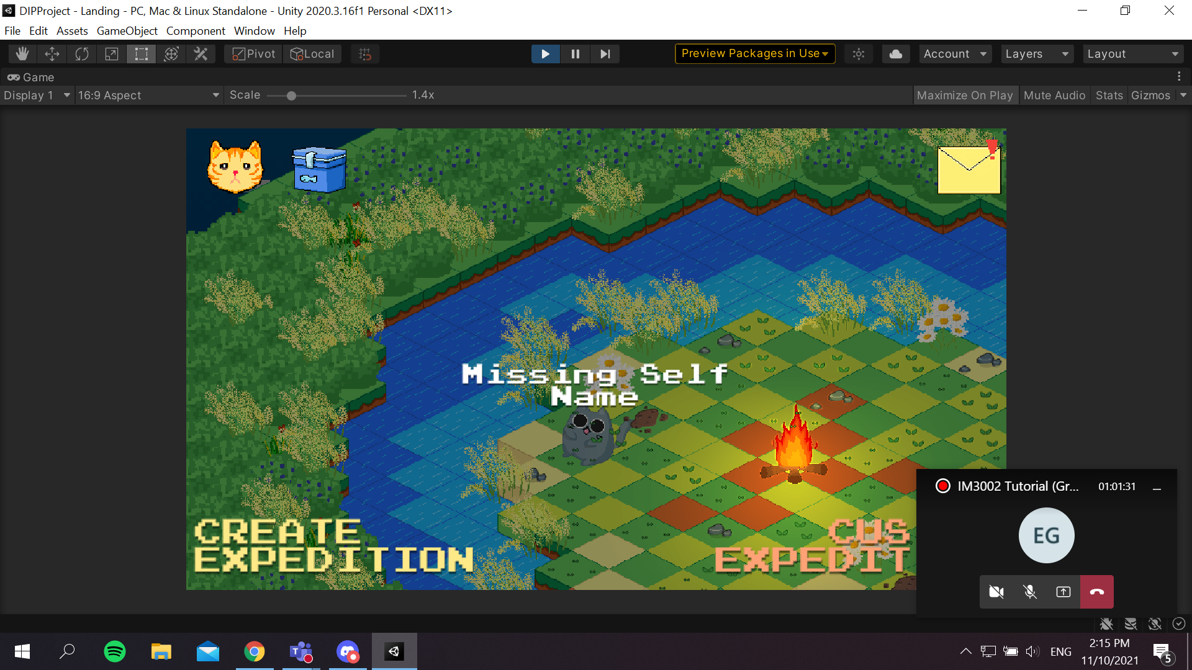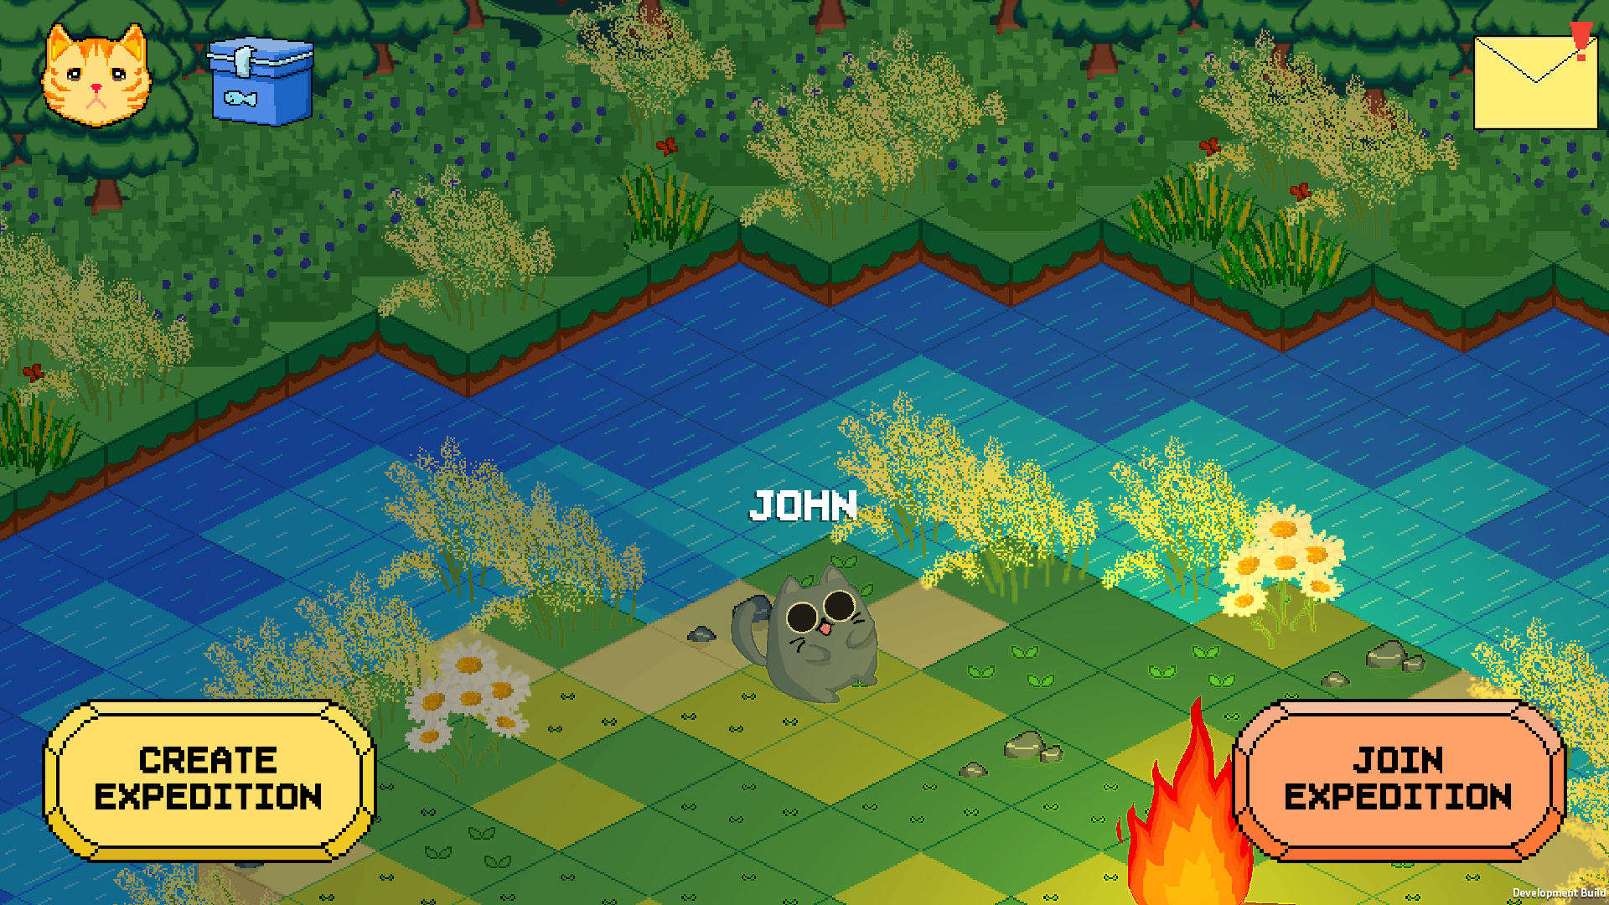

*Figure 10: Grass rendered first after the Y-axis sorting code*

Animated water tiles were also implemented to make the scene more interesting. Unity contains a “2D Tilemap Extras” package that has a feature to create animated tiles, which also works for our isometric tiles. Multiple sprites of water were drawn to create a single animated water tile.

### 4.3.2.4 Lighting and Normal Mapping

Unity provides experimental 2D lights that we can add to enhance our scenes through the “Universal Render Pipeline” package. We have also created a few sprites such as an animated campfire and camping lights that will represent the light source in-game.

2D lights can interact with normal maps to create dynamic lighting in our scene. “Normal” here refers to the normal vector which is the vector orthogonal to each face of the isometric tile. “Normal mapping” refers to describing that direction in the isometric tile with a secondary texture. The way that 3D graphics describe direction is in the colour.

 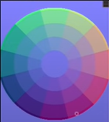 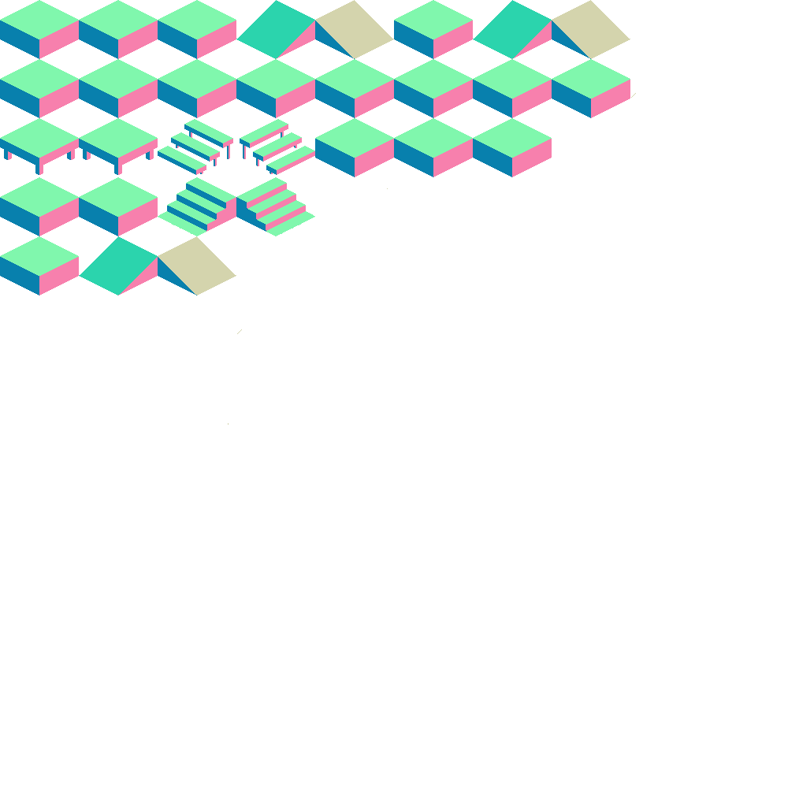

*Figure 11: Lighting*

The colours of the normal tile on the right are selected based on the colour wheel for normal mapping. This allows our 2D tile to behave like a 3D tile, and we can see the difference through how the tile responds to light (Figure 12). This makes the lighting in our tilemap environment more dynamic.

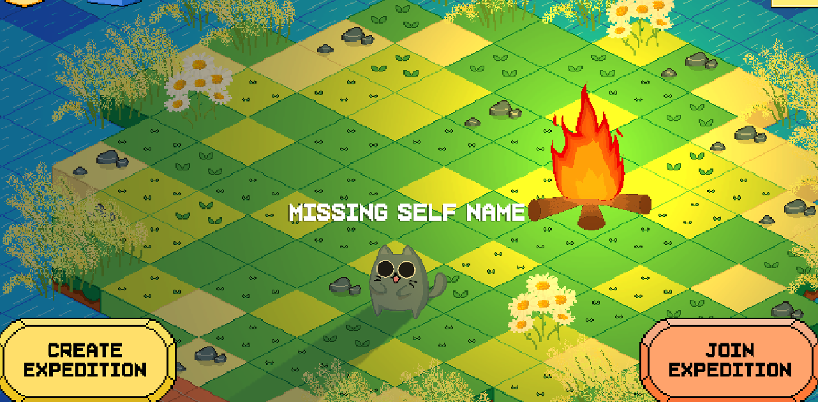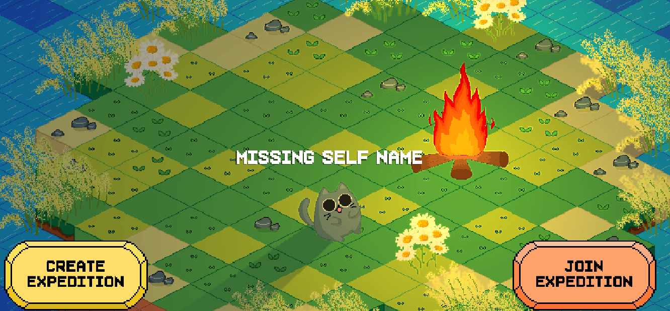

*Figure 12: Campfire looks more natural after “normal map” (applied on the right)*

### 

### 4.3.2.5 Tilemap themes

A variety of tilemaps (Figures 13, 14) were made so that users would have more to choose from and make our app more exciting. These include a tilemap for every season, and a “Chinese Garden” one for our local, Singaporean context to tie in with the name of our app.

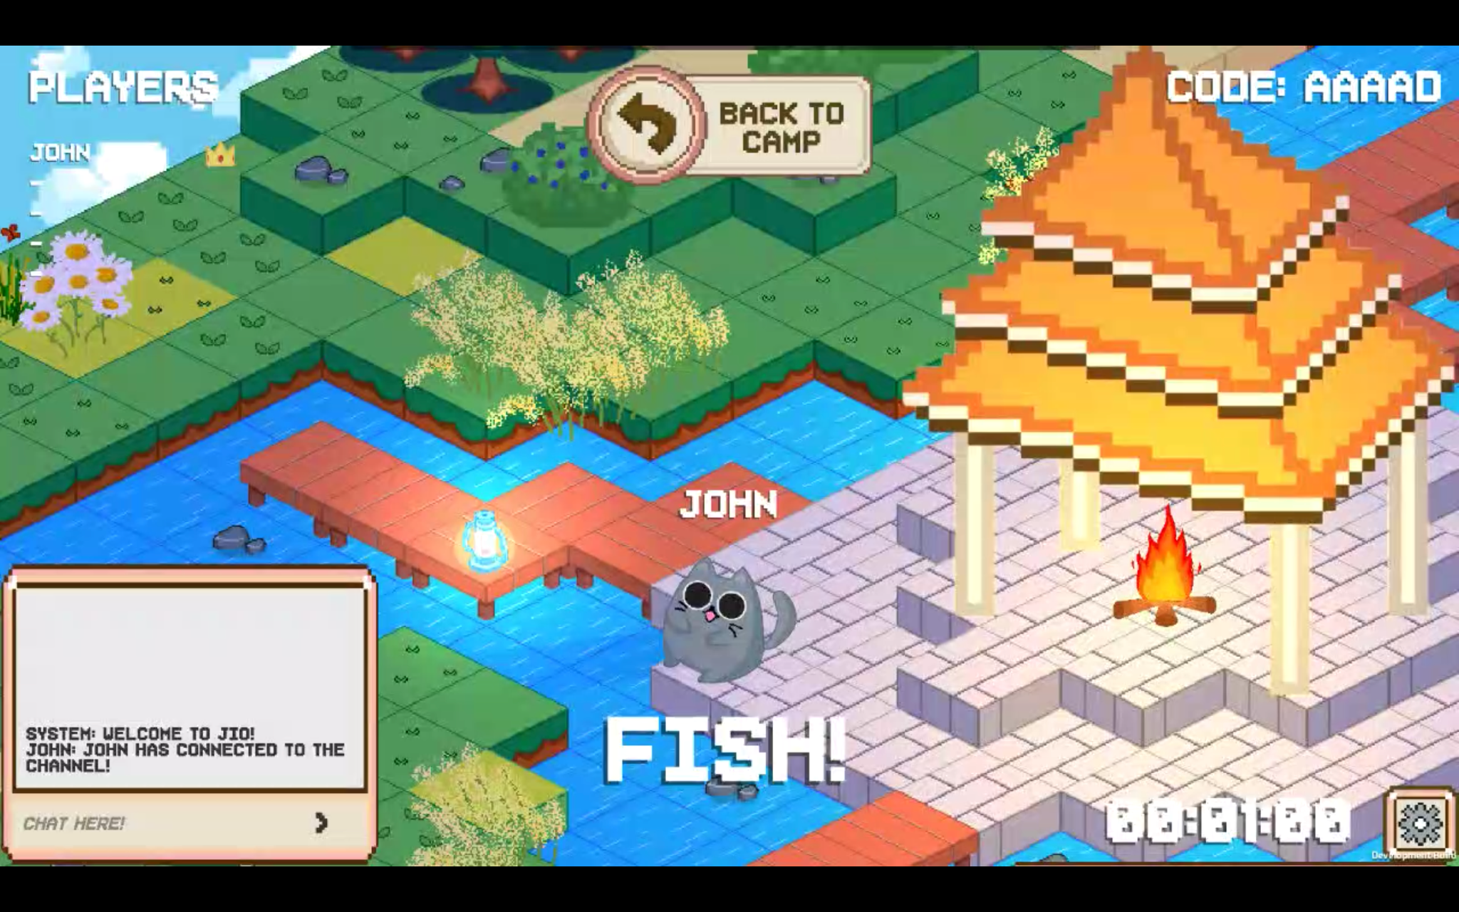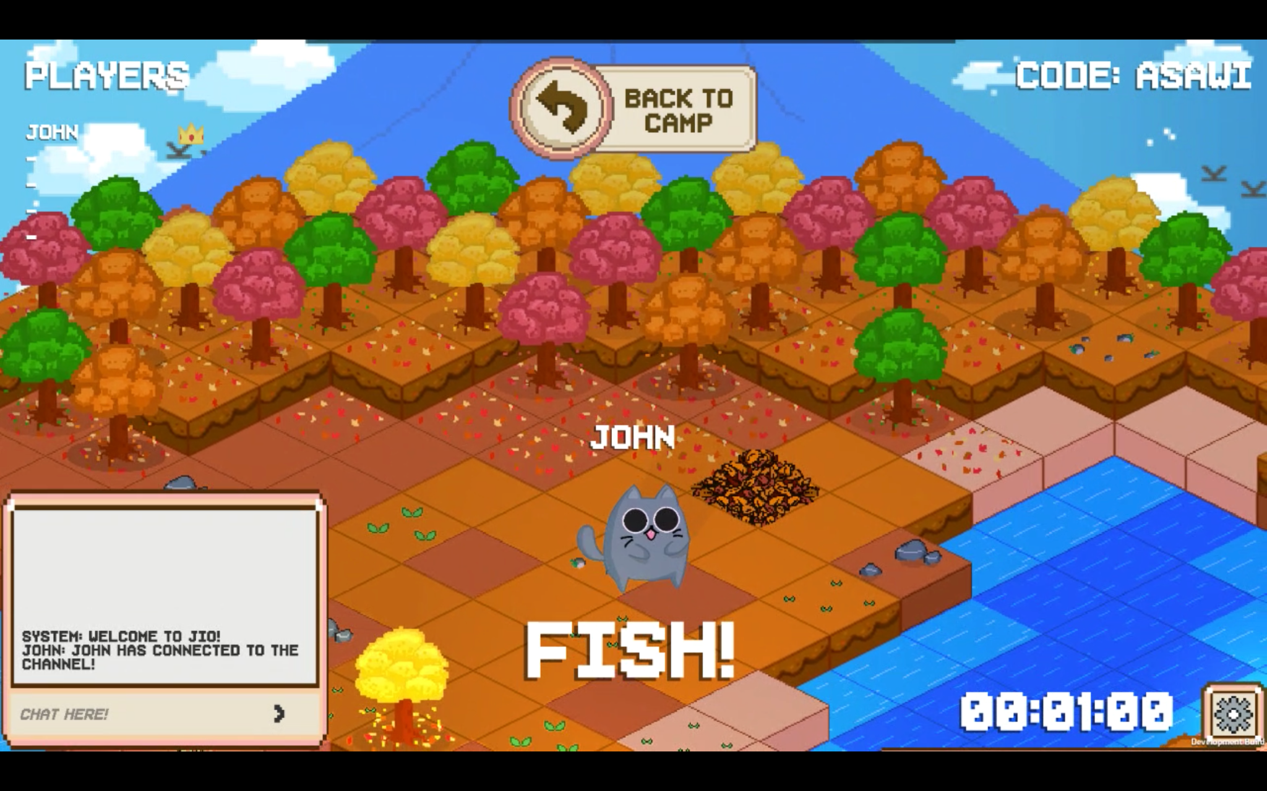

*Figure 13: “Chinese Garden” (left) & Autumn (right) tilemaps*

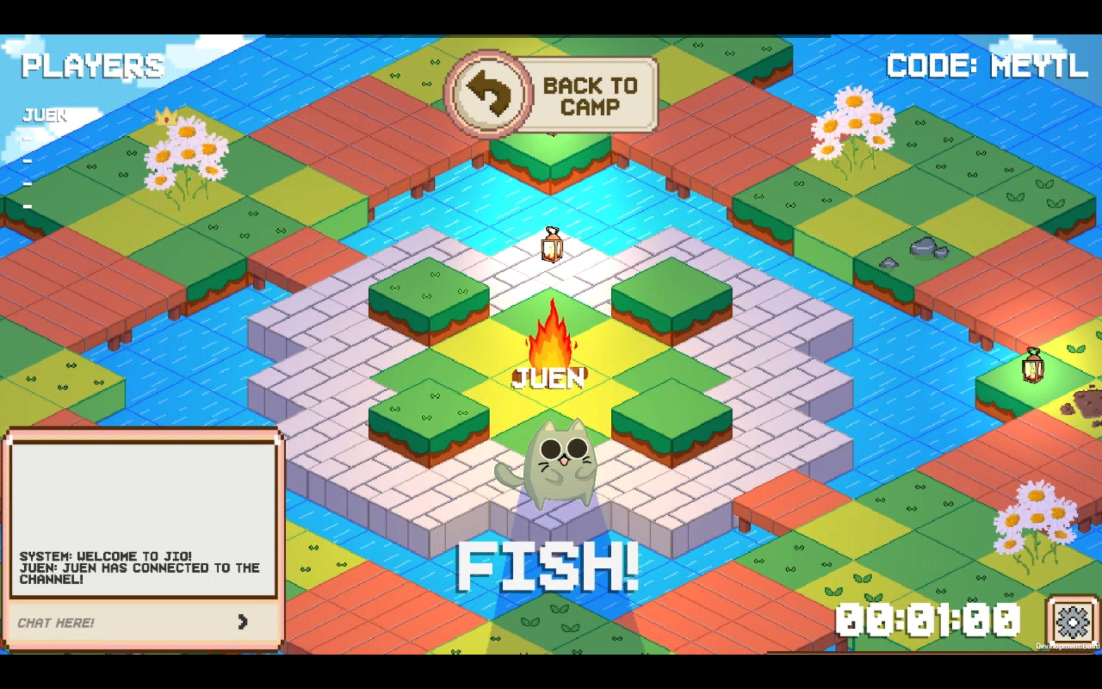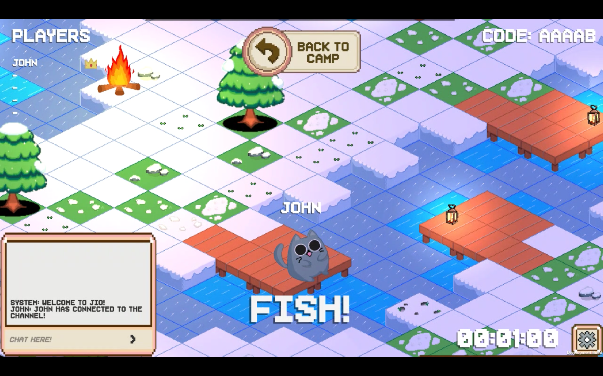

*Figure 14: Spring (left) & Winter (right) tilemaps*

#### 4.3.3. Animation using State Machine Programming

With regards to animating our cats in Unity, for utmost efficiency and ease, we have decided on using State Machine Programming.

The basic idea is that a character is engaged in a particular kind of action at any given time. The actions we decided to include in our game include idling, walking, and fishing. These actions are referred to as states.

In general, the character will have restrictions on the next state it can go to rather than being able to switch immediately from any state to any other. The options for the next state that a character can enter from its current state are referred to as state transitions. Taken together, the set of states, the set of transitions, and the variable to remember the current state form a state machine.

The importance of state machines for animation is that they can be designed and updated quite easily with relatively little coding. Each state has a Motion associated with it that will play whenever the machine is in that state. This enables an animator or designer to define the possible sequences of character actions and animations without being concerned about how the code will work.

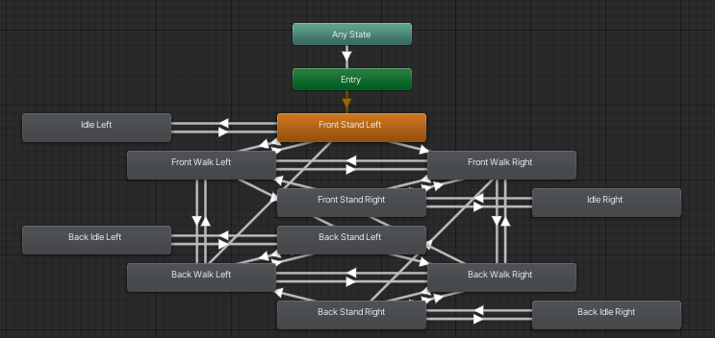

*Figure 15: State Machine Flowchart*

For our game, we animated our cats using Unity’s Animation State Machines. Our cats transit from one state to another according to the diagram shown above (Figure 15).

As we have four playable cats, animating them manually one by one would be too much of a hassle. Hence, we implemented reskinning of the characters using a script that allows us to change the characters but retain the animations done without having to redo the whole animation process (Figure 16).

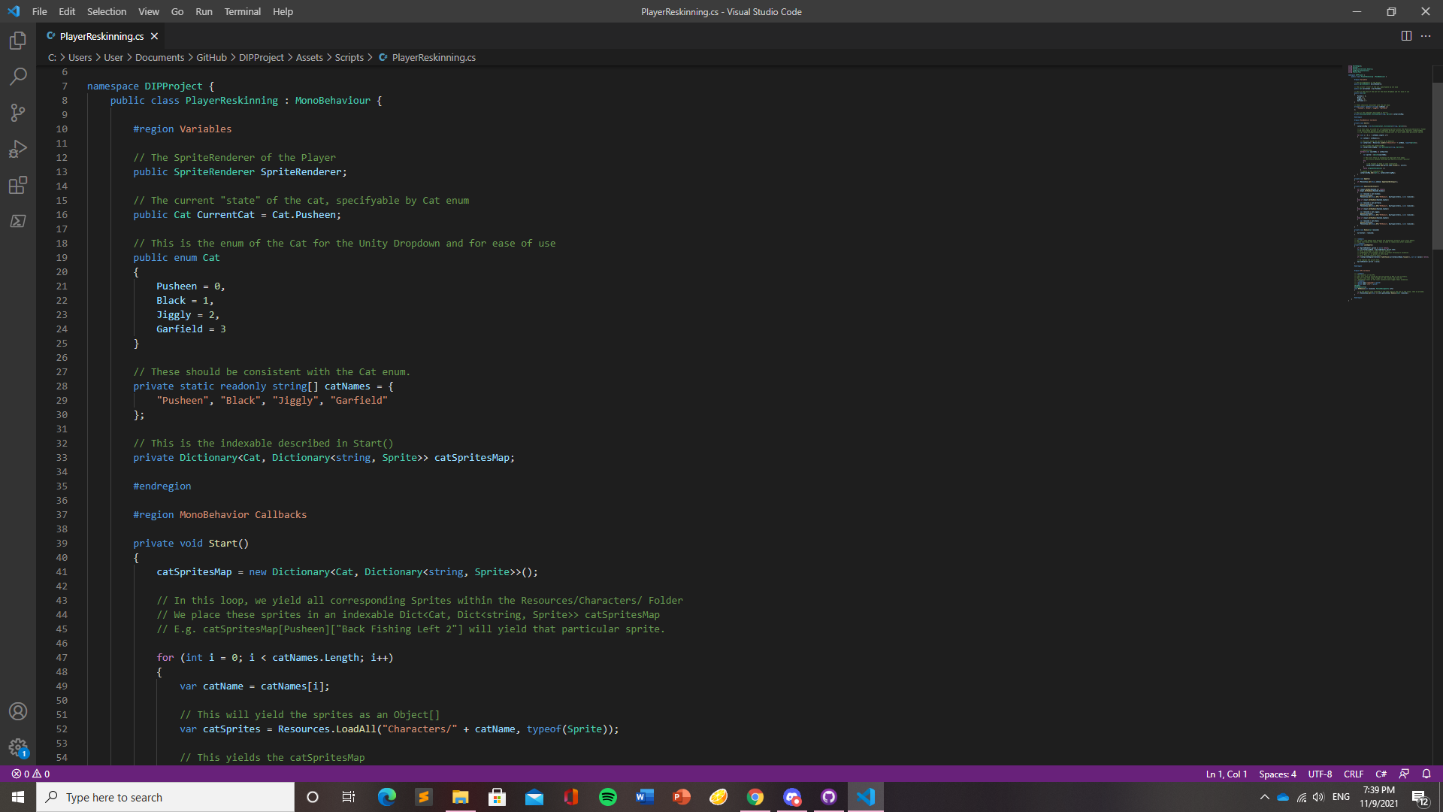

*Figure 16: Example of .cs script for reskinning animations*

We are now able to switch between the different cats in the game and all of the cats will have the same animation.

#### 4.3.4 Multiplayer Networking

#### 4.3.4.1 Photon Overview

Photon is a Unity Networking Package for multiplayer games.

The use-case is simple: Register in Photon and link the Unity Instance to the Photon Account. This resolves many multiplayer setup problems such as:

1. Dedicated Host
2. Host-Client Communication
3. Server Configuration
4. Security Configuration

### 4.3.4.2 Clients, Instances & Server

One interesting problem is handling the true state of each GameObject.

For example, **Alice & Bob** are on a server. **Alice** is seeing both Player Alice & Player Bob within their client, likewise with **Bob**. This means there are **4 GameObjects** across all clients! However, there should only be **2 players**, thus we **synchronise** Players on both clients separately. This is where **Photon Views** comes in.

### 4.3.4.3 Photon Views

In Photon-driven games, player GameObjects are identified using a PhotonView Component across clients, this allows consistent synchronization of variables. This is an essential backbone to the Photon ecosystem, allowing components such as Transform, Animation & States to be synced automatically.

However, some custom trigger events such as a Teleport Event or Chat Event must be manually done through **RPCs & Raise Events**.

## 4.3.4.4 RPCs & Raise Events

Remote Procedure Calls (RPCs) and Raise Events are ways to send data to all clients, the main difference is in the implementation.

### RPC Example:

Let’s say I want to tell other clients about my movement state as an integer. I would call this function.

| _photonView.RPC("RPCTrigger", RpcTarget.Others, (int) movement); |
| --- |

The clients receiving the data would receive the data through an RPCTrigger implemented below.

| [PunRPC] void RPCTrigger(int movementId, PhotonMessageInfo info) |
| --- |

### Raise Event

Let’s see the syntax for Raise Event for the same scenario

| PhotonNetwork.RaiseEvent(SyncMovementCode, (int) movement, ...); |
| --- |

SyncMovementCode is a unique integer identifying the event code.

Clients would receive the data through OnEvents

| public void OnEvent(EventData photonEvent) |
| --- |

## When to use which

RPCs associate its call to a PhotonView callee, while RaiseEvents don’t. Thus RPCs are suitable for player-to-player interaction. While RaiseEvents are for room-side events.

In the context of our game:

| RPC | | | | |
| --- | --- | --- | --- | --- |
| Fishing Total Time | Fishing Timer | Fishing Start | Fishing End | Fishing Set Timer |
| Raise Events | | | | |
| Voice State | Player Animations |  |  |  |

## 

## 4.3.4.5 Photon Room System

There are 2 main areas in the Photon Room ecosystem, Lobby & Room.

Within a lobby, the players choose rooms to go into. Rooms are dynamically created and are uniquely identified with their room name. Only players in the same room can interact with each other.

## 4.3.4.6 Photon Chat & Voice

Photon Chat uses a simple structure similar to Photon Rooms. However, it uses the subscription of channels. If Alice subscribes to Channel A and B, they can see messages from A & B regardless of what room she joined.

In our application, we linked the channel to the room name, thus if Alice joins room A, she will subscribe to channel A.

Photon Voice uses the same structure as Photon Chat, and has an implementation of a muting & echo debug function

#### 4.3.5 Database

For an app such as JIO, users need to be able to take ownership of their unique usernames in order to save their statistics and inventory for future logins. To achieve this, a database is needed for authentication and to keep inventory.

We have chosen Amazon Web Services (AWS) to host our database, specifically the Relational Database Service (RDS). A relational database is perfect for our app as we need tables that can present the relationships between usernames, passwords, and inventory in a concise manner. Any edits to the data points will be easier as well.

From here, it is just a matter of integrating MySQL queries into Unity3D’s native language.

## Conclusion and Recommendation

### 5.1 Conclusion

All in all, we have managed to successfully create an app that encompasses both of our initial objectives - a social app that promotes productivity. Each room can support up to 20 players without any issues and are well equipped with functions like text and voice chat to facilitate intelligent discussions while ensuring that users do not get too distracted with other functions on their phone.

### 5.2 Recommendation for Future Works (sustainability)

**5.2.1 Orientation of App**

Since our app features an isometric tilemap, it is best displayed on the landscape orientation. This may be inconvenient for users that rarely interact with apps that require such constraints. Therefore, developing a version of the app that is compatible with the portrait orientation could be useful to attract a larger user base.

#### 5.2.2 Economics

Due to the lack of time, the economics system of the app has not been fully fleshed out. As users are rewarded with different fishes after a successful expedition, a larger variety of fishes they could collect would be ideal.

However, since JIO is a productivity app at its root, the economics in-app should not be overly complex so as to ensure that users do not spend too much time on customising features within the app itself. Therefore, a recommended system would simply be for users to spend the fish (in-app currency) for collectibles. This would allow for better continuity within the app, enticing users to return so as to gather more collectibles.

#### 5.2.3 Diversifying Variables

To allow for more customisation in-app, more cats (in-app avatar for users) and more tilemaps could be added, allowing users more options and therefore keeping them from being fatigued by a lack of choices.

#### 5.2.4 Background Music & White Noise

Ambient music or white noise could be implemented, as some users may prefer some background sounds when they are being productive. This can make our app more convenient since users would not need a separate application to access these sounds.